

SHOP RENTAL AGREEMENT

Owner (First Party’s):

Mary Margaret Costa, Father’s Name: Michael Rosario, Mother’s Name: Cecilia Rodrigues, Permanent Address: House/Holding: 16/C, Village/Road: East Rajabazar, Post Office: Tejgaon - 1215, Tejgaon, Dhaka North City Corporation, Dhaka. Nationality: Bangladeshi, National ID Card No- 8227341917, Religion: Christian, Profession: Business.

Tenant (Second Party’s):

Haydar Paik, son of Mohabbat Paik, Permanent Address: Village- Fatehpur, Post Office: Fatehpur-9300, Bagerhat Sadar, Bagerhat. Nationality: Bangladeshi, Religion: Islam, Profession: Business. National Identify No.: 9107378607.

Taking the name of the almighty Allah we like to start writing description of this rental deed for the below schedule Mouza: Shenpara Porbota, P.S- Mirpur, Dist- Dhaka, Shop No: 185 (1800 Sft). We both the parties 1st and 2nd get agree to take and give the rent by maintaining the following terms & conditions.

Terms And Conditions

- The below schedule Shop made rented to the second party’s by the said 1st party’s for a period of 5 years. The period will be 05/06/2024 AD to 04/06/2028.


- The monthly rent for the Shop: 185 (1800 Sft) is 1,20,000/- (One Lac Twenty Thousand) Taka, which will be paid by the second party to the first party. The rent for the current month must be paid by the 10th of the respective month.
Cont. Page- 02





Page-02

- No illegal activity or illegal business is allowed in the Shop.

- After completing the period if the 2nd party’s likes to rent the Shop again then first party’s could rent to the 2nd party’s subject to fulfill his terms.

- The Shop is not allowed to use with anti-state activities or illegal trade, performing immoral, unsocial act. If such is done first party’s will not be responsible at anyhow. If any proof of doing such act is found the 2nd part will be compelled to leave the Shop with in 01(one) week.

- As soon as completing the term Shop will be vacated by the 2nd party’s in favor of the 1st party’s keeping it with previous state. If any expense arises for returning the Shop with previous condition 2nd party’s is to bear such expense.

- Tenant of the Shop is to allow new proposed tenant to see the Shop.

- Second party’s is to oblige maintaining procedure of using Shop taken by the Shop owner and should be careful to create any trouble for the other residents of the Shop.


Continue Page-3





Page-3

In this regard, voluntarily, knowingly, in good health, and without any external provocation, having understood all the terms of the aforementioned rental agreement, I, the undersigned, hereby execute and sign this Shop rental agreement in the presence of the witnesses.

This Deed of Lease Agreement is completed in three typed pages and attested by witness: WITNESS HEREOF the parties have signed this deed on the date, month and year mentioned herein above accepting the Terms and Conditions thereof.

Witness Signature:  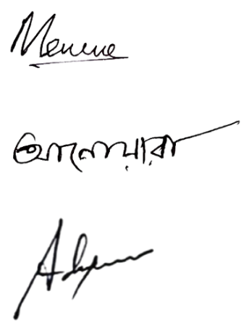  1.  2.  3. | 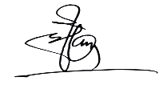  Signature:  First party/owner  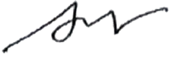  Signature:  Second party’s/Tenant.

